SWE Membership Join/Renewal Instructions

Tip: When selecting membership level, we strongly recommend Collegiate 2 Career (C2C). If you have two or more years of undergraduate education left, it is the best deal.

Instructions to Join
- https://support.swe.org/support/solutions/articles/35000070236-join-reinstate-instructions
- When prompted for section number, be sure to enter “D061” for the Georgia Tech section.
- Complete this Google Form.

Instructions to Renew
- Log in to the SWE Member Portal.
- Click “SWE Membership Renewal.”
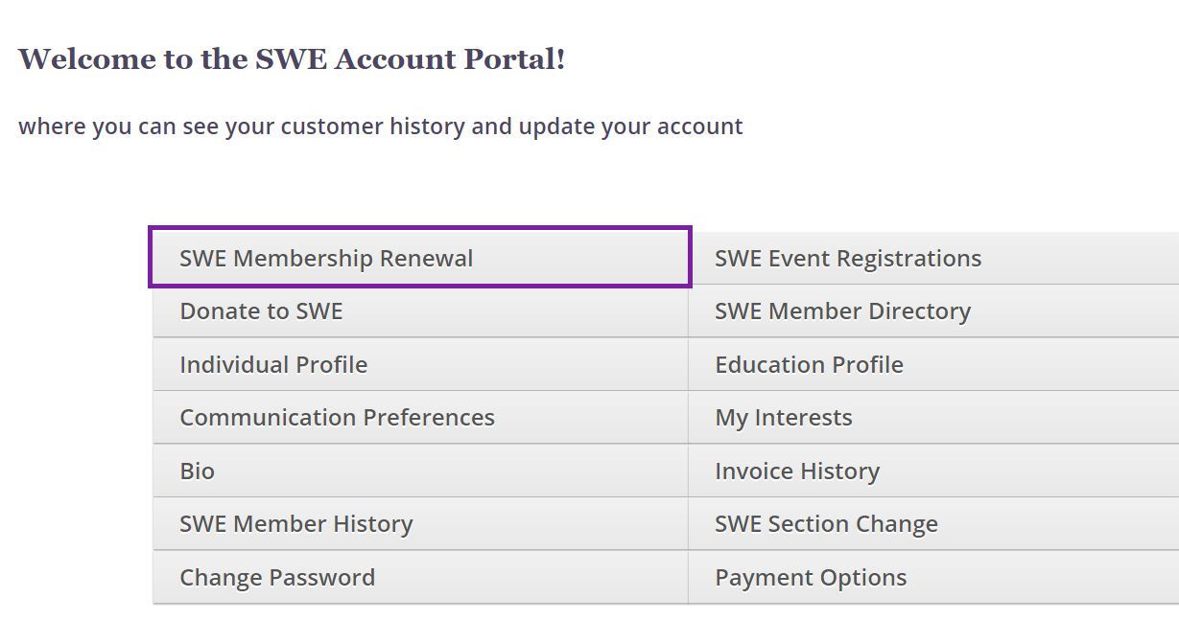

- Select Membership Level.
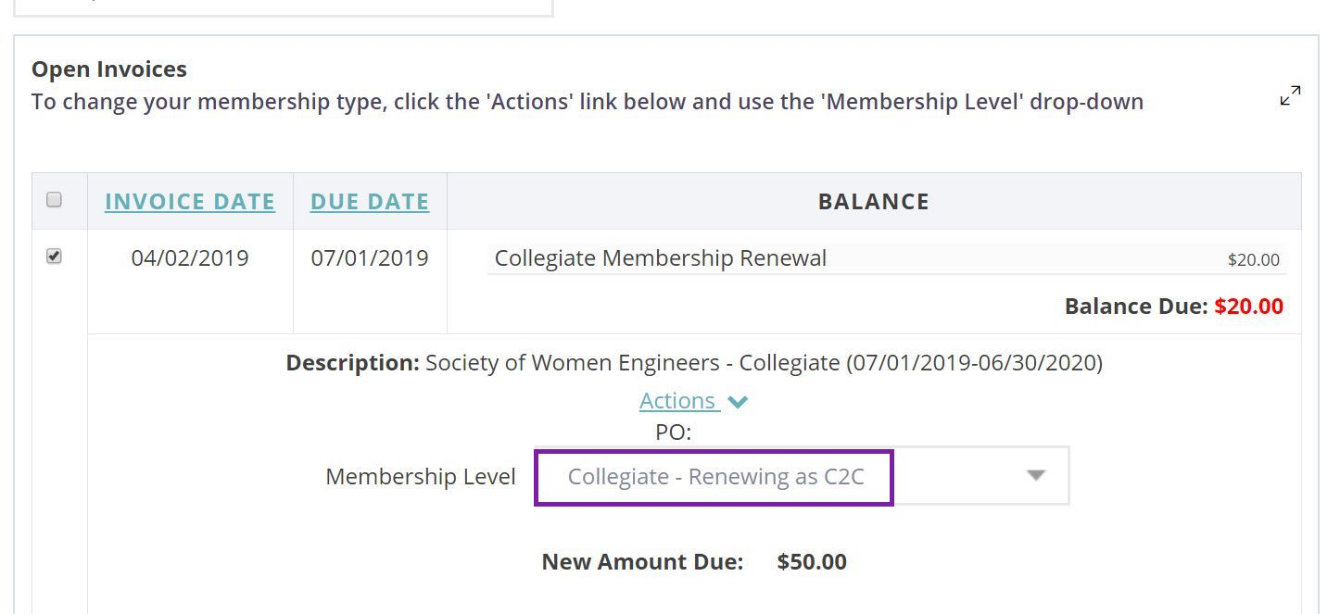

- Continue and follow payment instructions.
- Complete this Google Form.

For questions, please contact Tina Lu at swevpmembership@gmail.com.

